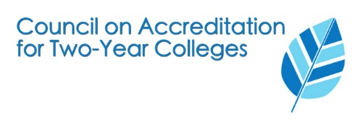
Call For Proposals
Council for Accreditation of Two Year Colleges Fall 2020 Annual Conference
Conference Theme: “Innovation in the Heartland” September 13 – 15, 2020
Instructions: Complete this form and email to: Meganf@labette.edu
Submission Deadline: April 10, 2020

Proposed Session Title:

Proposal addresses which of the following HLC Criteria:

- 1. Mission
- 2. Integrity: Ethical and Responsible Conduct
- 3. Teaching and Learning: Quality, Resources, and Support
- 4. Teaching and Learning: Evaluation and Improvement
- 5. Resources, Planning, and Institutional Effectiveness

Presenter(s):
Name:

Job Title:

Phone: Email:

Institution:

Name:

Job Title:

Phone: Email:

Institution:

Name:

Job Title:

Phone: Email:

Institution:

Session Description

Please provide a description of your proposed session. (500 Word Maximum)

Please provide a brief description (50 word maximum) that may be used to publicize your session.

In 250 words or less, please explain how your session is relevant to the conference theme.

Completed session proposal forms should be scanned and emailed to meganf@labette.edu
no later than April 10, 2020.

